**Black History Month**

**“47” Alumni Association of the Deaf**

**celebrates Black History Month**

**in honor of**

**Eugene “Silent” Hairston**

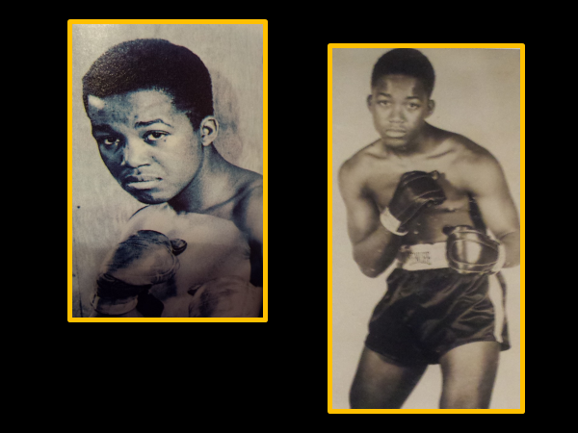

**First Deaf African-American Professional Boxer**

**(1947-1952)**

**Tuesday, February 11, 2020**

**1:15 pm - 2:00 pm**

**2nd Floor Library**

**A PowerPoint presentation will be use to describe**

**Eugene “Silent” Hairston’s legacy.**